|  |  |  |  |  |  |
| --- | --- | --- | --- | --- | --- |
|  | a | b | c | d | e |
| a | 0 | 1 | 0 | 1 | 0 |
| b | 1 | 0 | 1 | 1 | 0 |
| c | 0 | 1 | 0 | 0 | 1 |
| d | 1 | 1 | 0 | 0 | 1 |
| e | 0 | 0 | 1 | 1 | 0 |

無向圖相鄰矩陣

有向圖相鄰矩陣

|  |  |  |  |  |  |
| --- | --- | --- | --- | --- | --- |
|  | a | b | c | d | e |
| a | 0 | 1 | 0 | 0 | 0 |
| b | 0 | 0 | 1 | 1 | 0 |
| c | 0 | 0 | 0 | 0 | 1 |
| d | 1 | 0 | 0 | 0 | 0 |
| e | 0 | 0 | 0 | 1 | 0 |

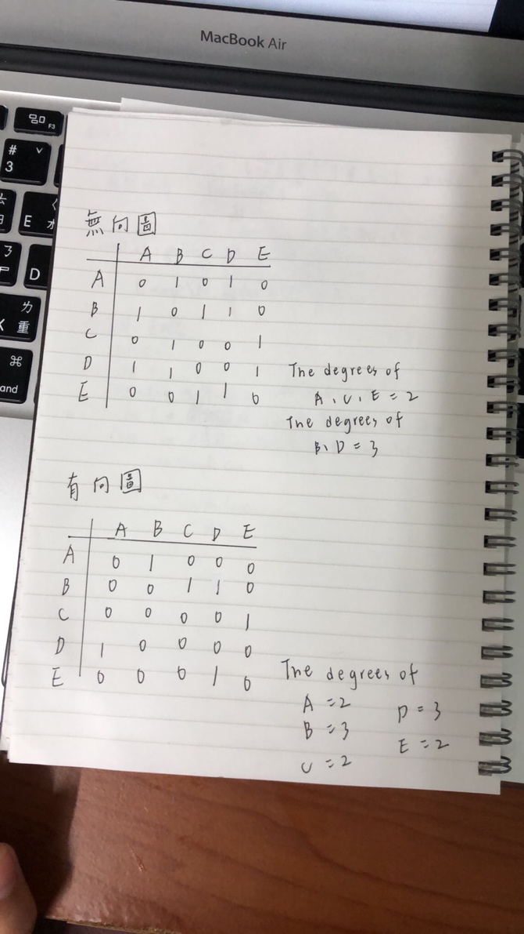

分支度:

Indegree + outdegree = degree

A:1+1=2

B:1+2=3

C:1+1=2

D:2+1=3

E:1+1=2

有向圖串列:

a->b /

b->c -> d/

c->e/

d->a/

e->d/